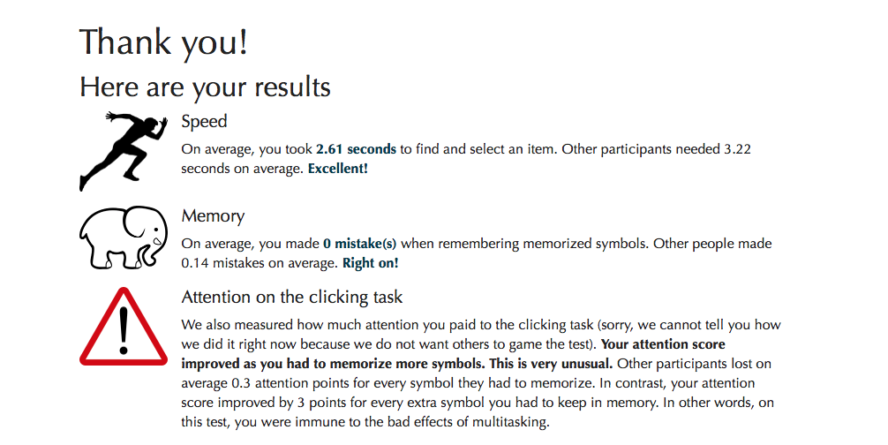

I feel like I don’t exactly agree with this statement that is shown here about the attention. This is because I really didn’t care about the beginning part until I started to memorize the letters that were shown. What stood out in the test is whenever I answered the memorization wrong, It would decrease the number of letters in the next test. Another thing I noticed was that with the recents column, I could quickly click and move on to the next letter. I learned that I can multitask as well as keep my speed and some memory at times.